1. Autoconfiguration in IPv6
Autoconfiguration allows devices to configure their own IP address automatically without a DHCP server.
Types:
Stateless Autoconfiguration – Device generates its own address using the network prefix (from router advertisement) + its interface ID.
Stateful Autoconfiguration – Works like DHCPv6, where the server provides the address and configuration.
Benefit: Makes network management easier, especially for large networks like IoT.

2. Renumbering
Renumbering means changing IP addresses in a network when:
Switching to a new ISP.
Changing network topology.
Moving from IPv4 to IPv6.
IPv6 supports easy renumbering because of autoconfiguration and router advertisements.
In IPv4, renumbering is manual and time-consuming.

3. Comparison between IPv4 and IPv6
Feature | IPv4 | IPv6
Address Size | 32-bit (≈ 4.3 billion addresses) | 128-bit (≈ 340 undecillion addresses)
Address Notation | Decimal, dotted (192.168.0.1) | Hexadecimal, colon separated (2001:0db8::1)
Configuration | Manual / DHCP | Auto (Stateless) + DHCPv6
Security | Optional (IPSec) | Built-in (IPSec mandatory)
Broadcast | Supported | No broadcast (uses multicast/anycast)
Header Size | Variable | Fixed (40 bytes)
NAT (Network Address Translation) | Common | Not needed (huge address space)

4. BOOTP vs DHCP
Feature | BOOTP (Bootstrap Protocol) | DHCP (Dynamic Host Configuration Protocol)
Purpose | Assigns IP to diskless workstations | Assigns IP + full configuration (DNS, gateway, lease time)
Static/Dynamic | Mostly static | Supports both static and dynamic
Manual Effort | Requires admin configuration | Automatic, flexible
Popularity | Old, rarely used | Modern, widely used

5. Transition Strategies (from IPv4 to IPv6)
Dual Stack
Devices run both IPv4 and IPv6 at the same time.
Allows communication with both networks.
Simple but uses more resources.
Tunneling
IPv6 packets are encapsulated inside IPv4 packets to travel over IPv4 networks.
Useful when IPv6 is not fully deployed.
Example: 6to4 tunneling.
Header Translation (NAT64/NAT-PT)
Converts IPv6 header into IPv4 header and vice-versa.
Enables IPv6 devices to talk to IPv4 devices.
Some information may be lost in translation.

6. Advantages of IPv6
Enormous address space.
Faster routing with simplified headers.
Built-in security (IPSec).
No need for NAT.
Better QoS (Quality of Service) support.
Easier autoconfiguration and renumbering.
Mobility support for mobile devices.

IPv6 Packet Format
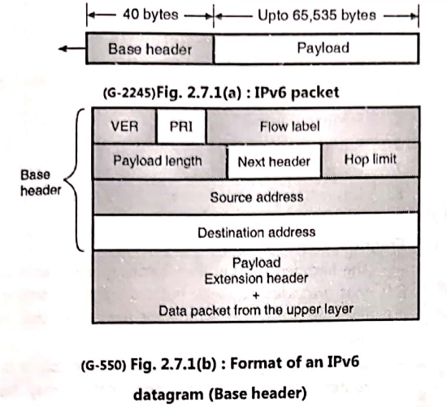
IPv6 header is fixed 40 bytes. Fields include:
Version – IPv6 (value = 6).
Traffic Class – Similar to ToS in IPv4 (priority).
Flow Label – For real-time traffic (like voice, video).
Payload Length – Size of data after header.
Next Header – Type of extension header (e.g., TCP, UDP).
Hop Limit – Like TTL in IPv4.
Source Address – 128-bit address of sender.
Destination Address – 128-bit address of receiver.

8. Payload in IPv6
The payload is the actual data carried by the packet after the IPv6 header.
Can be:
TCP/UDP segment,
ICMPv6 message,
Or any higher-level data.
Payload Length field tells its size.
With extension headers, payload handling becomes more flexible.

What are Extension Headers?
In IPv4, the header had a lot of optional fields → making it complicated and variable in size.
IPv6 simplified things:
The main IPv6 header is fixed (40 bytes).
Any extra information is put in Extension Headers.
They are like “add-on packets” chained after the main header.

How Extension Headers Work
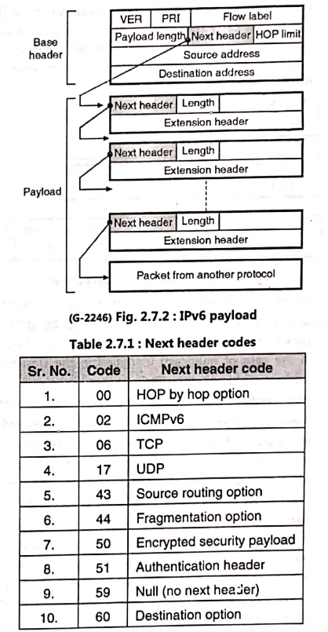
Basic Idea
Every IPv6 packet has a main header.
If more details are needed (like routing info, security, fragmentation), the packet includes extension headers in sequence.
Next Header Field
In the IPv6 header, there’s a field called Next Header.
It tells what comes after the IPv6 header:
Could be an Extension Header, or
Could be the final protocol (e.g., TCP, UDP).
Chaining
If there are multiple extension headers, each one also has a Next Header field to point to the next.
This creates a linked list (a chain) of headers.
Order of Extension Headers (RFC suggests an order):
Hop-by-Hop Options (info every router must read)
Destination Options (for final receiver)
Routing (defines specific path)
Fragment (if packet is split)
Authentication & ESP (for IPSec security)
Destination Options (again, for the last node before upper-layer protocol)
Upper Layer Header (TCP/UDP/ICMPv6 etc.)

